Silk Pajamas
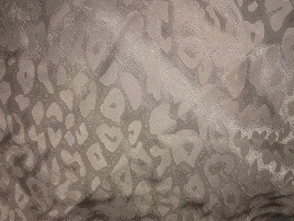
Characteristics:
- Applied white cheetah print design
- Tightly woven

Bedsheet
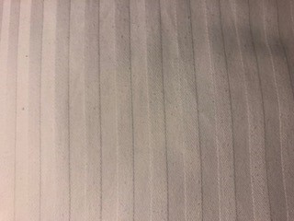
Characteristics:
- Cotton
- Structural striped design
- Woven

Sweatshirt:
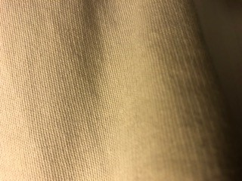
Characteristics:
- Knitted

